**LAPORAN PRAKTIKUM PEMROGRAMAN BEORIENTASI OBJEK**

“Tugas 03 - Inheritence*”*



Oleh:

Nama : Muhammad Zidan Ferdian

NPM : 4523210082

Kelas : A

Dosen:

Adi Wahyu Pribadi , S.Si., M.Kom

**S1-Teknik Informatika**

**Fakultas Teknik Universitas Pancasila**

**2024/2025**

**Source Code**

**karyawan.java**

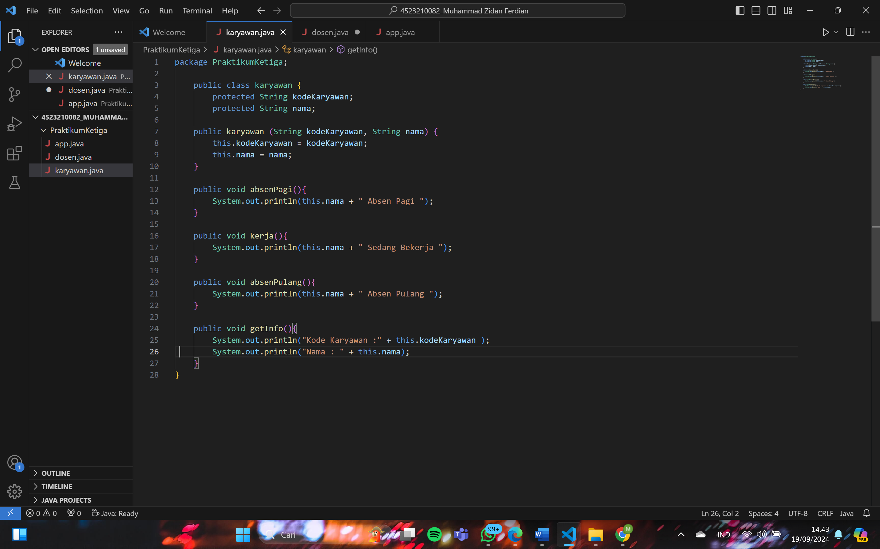

**dosen.java**

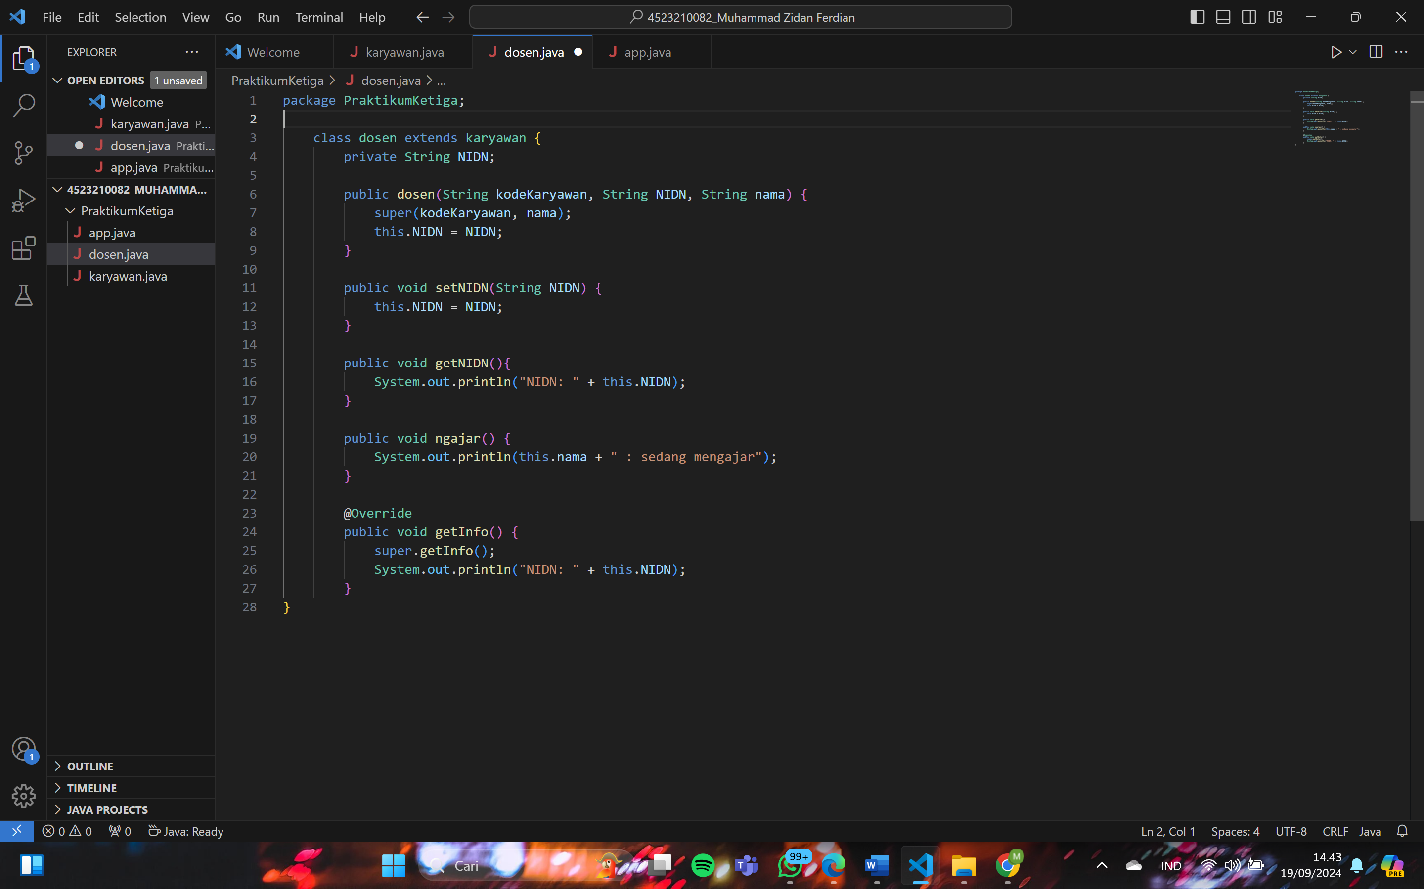

**app.java**

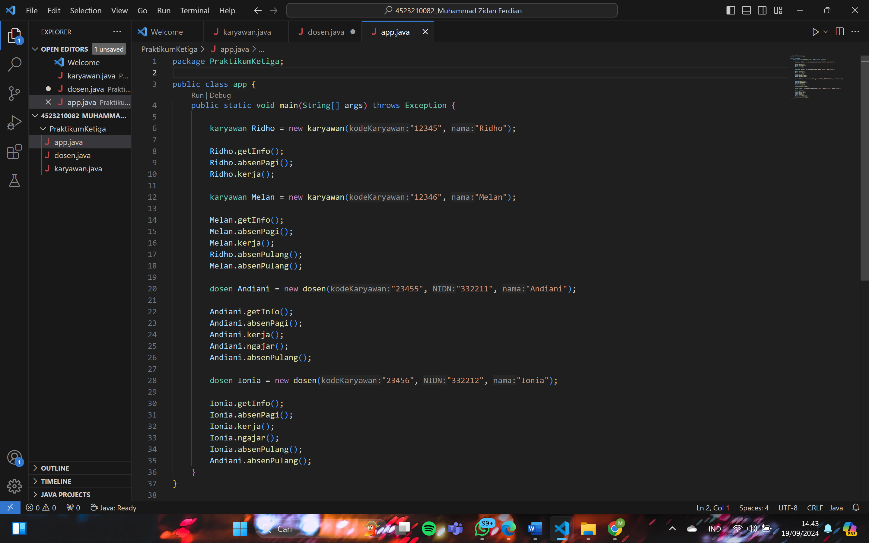

**Hasil Run/Debug**

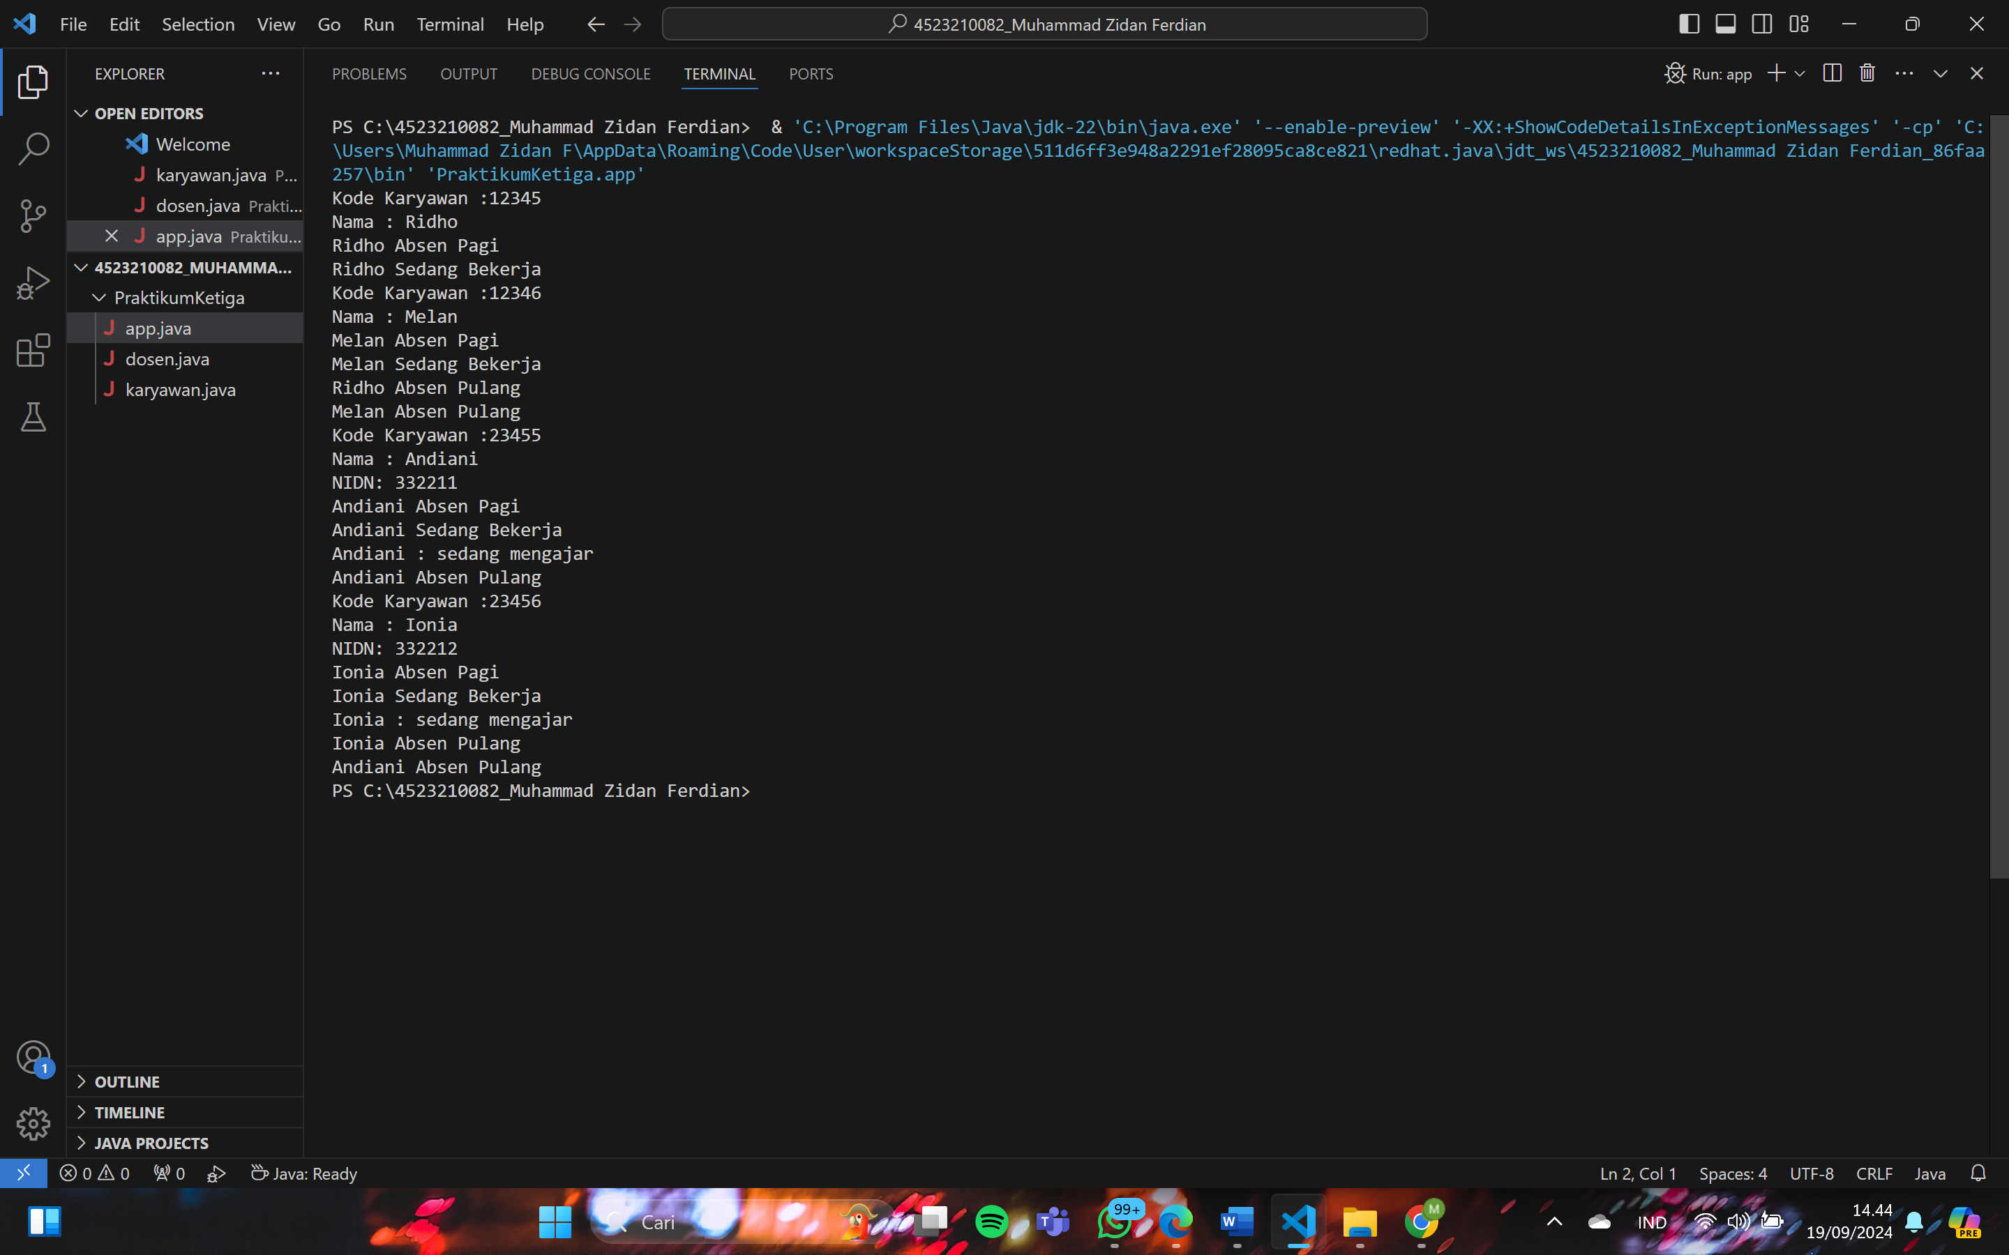

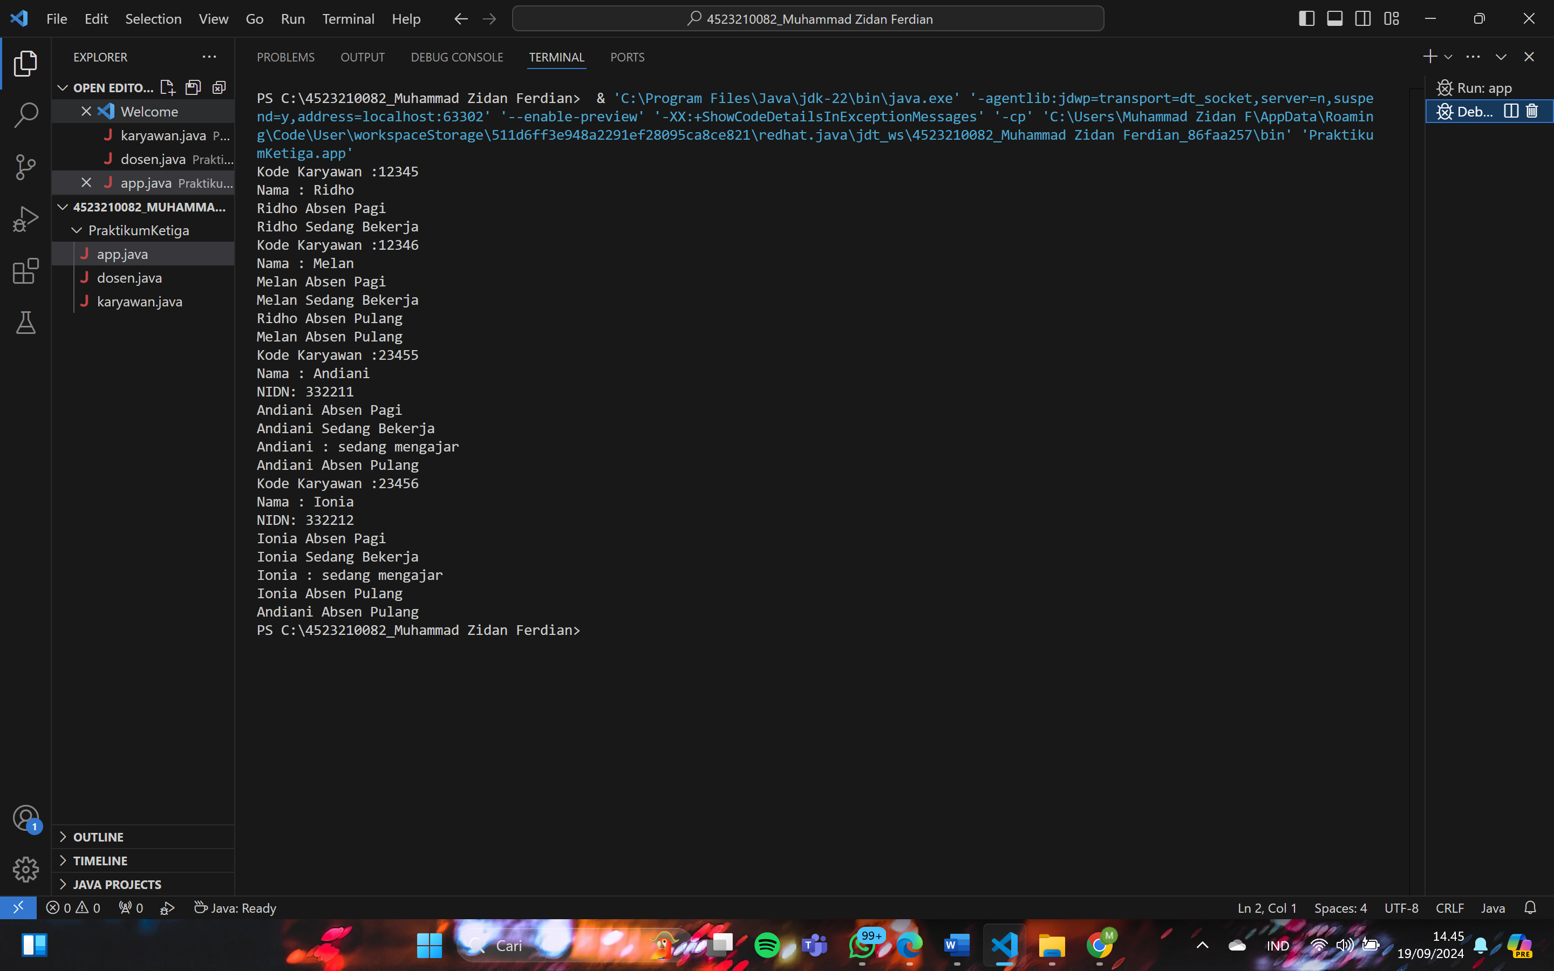

**Dxdiag :** 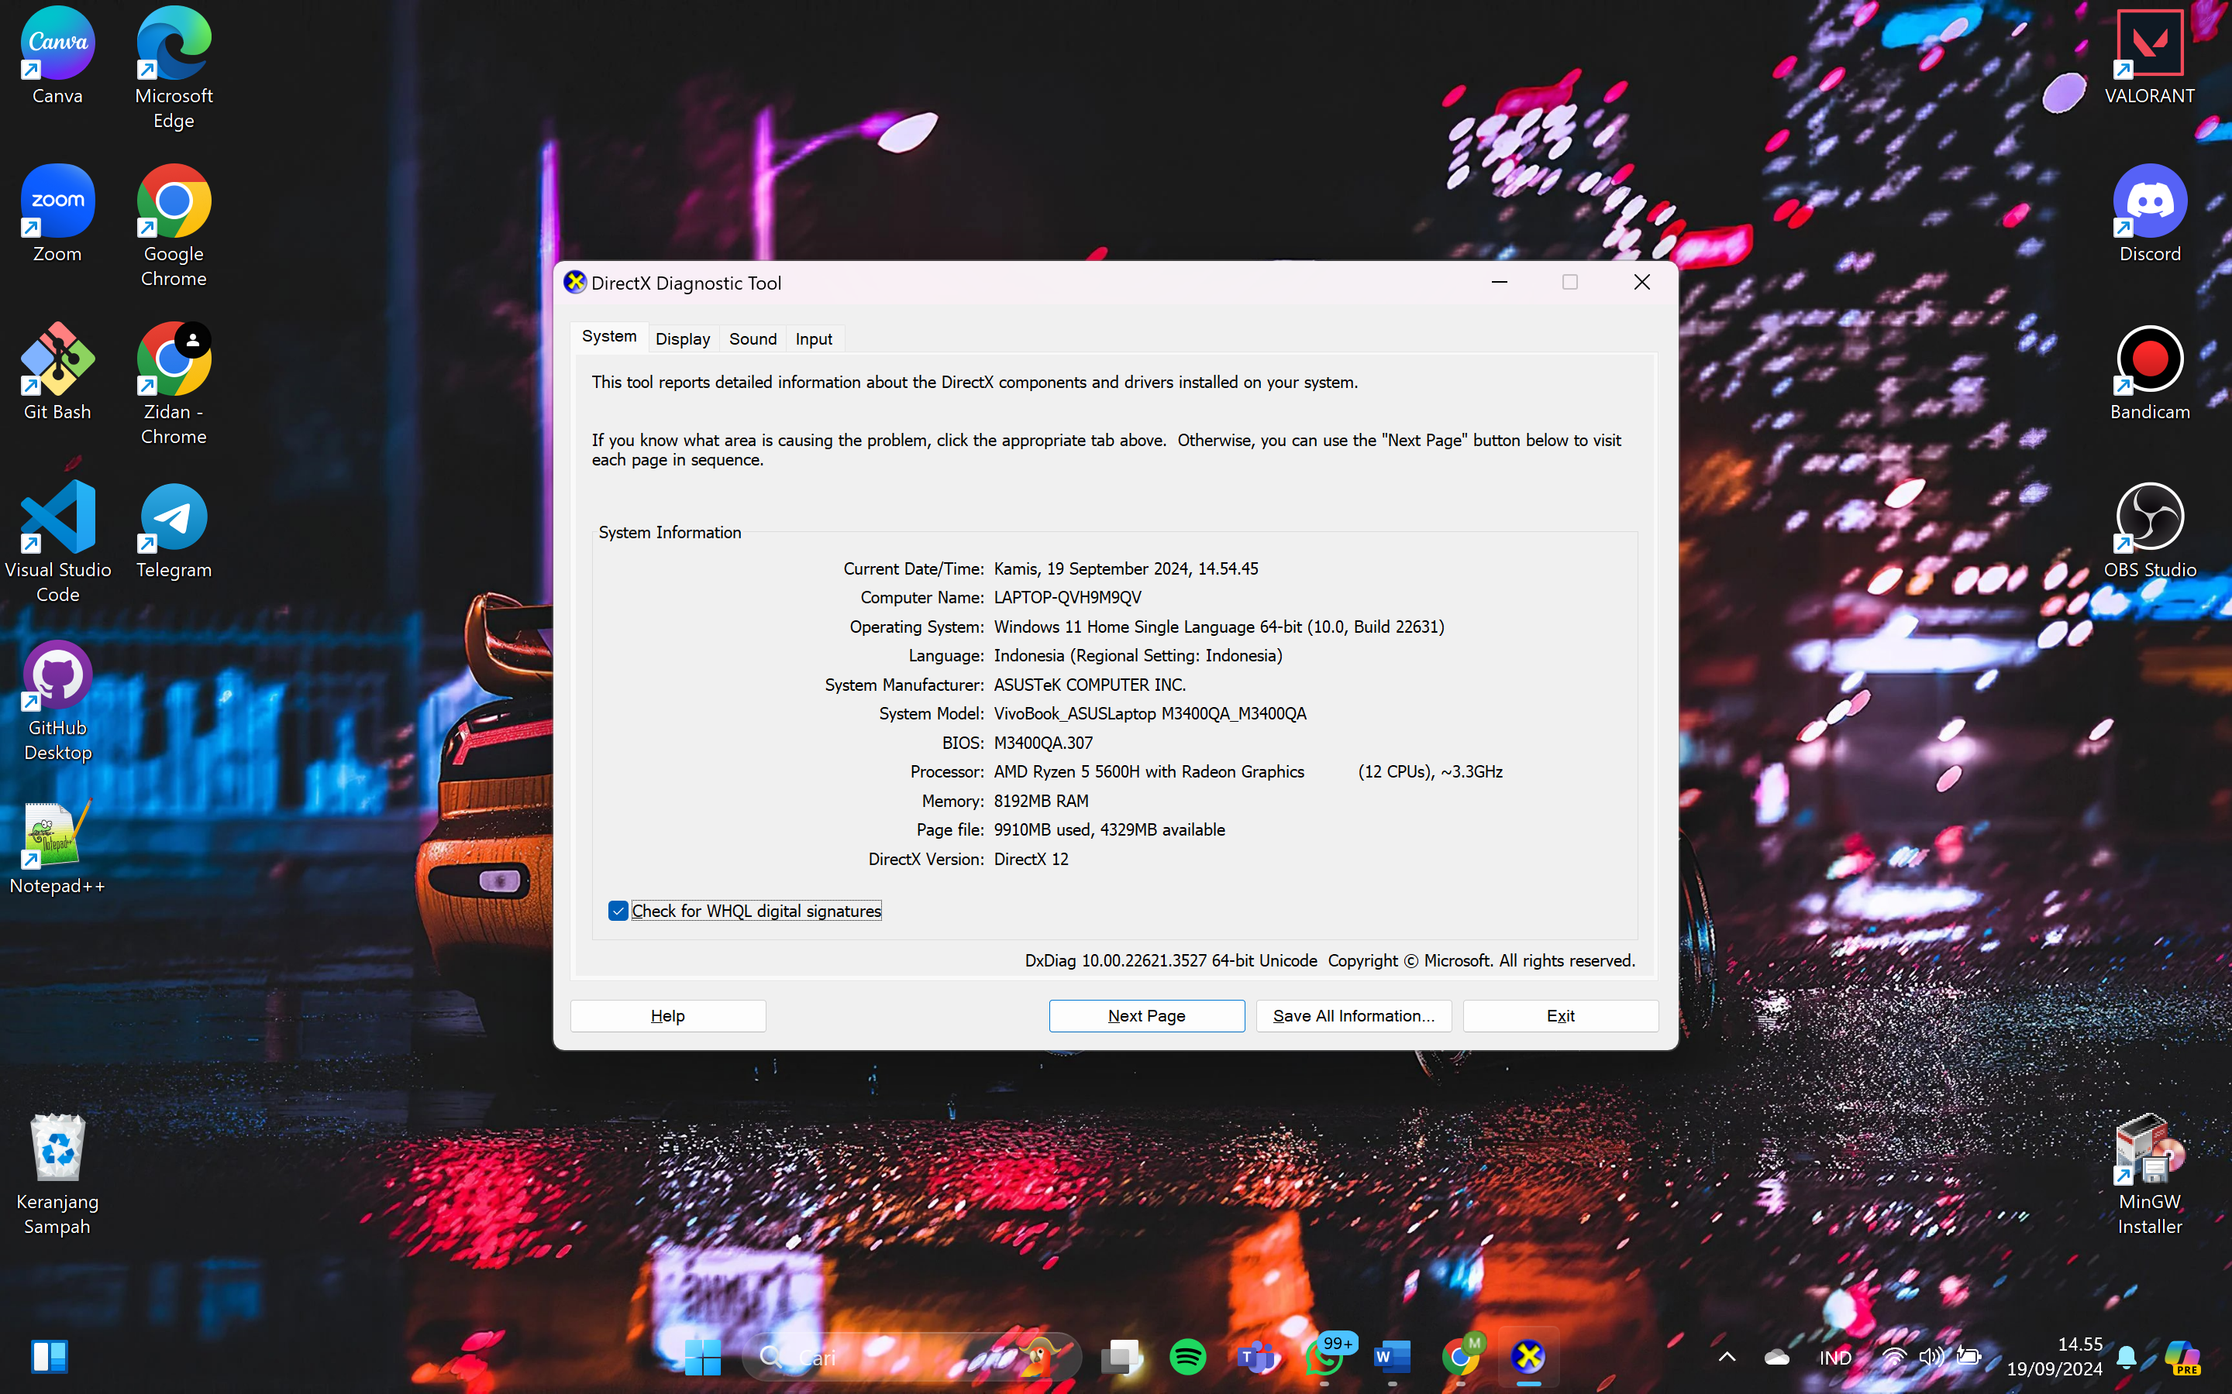

**Link Github :** [**https://github.com/emjettt/Praktikum03_PBO_A_4523210082_Muhammad-Zidan-Ferdian.git**](https://github.com/emjettt/Praktikum03_PBO_A_4523210082_Muhammad-Zidan-Ferdian.git)